Improvement of Machine Layout by Cellular Manufacturing

MUHAMMED SHABEEB V¹
M.E Scholar, Department of Mechanical Engineering, Kathir College of Engineering, Coimbatore, India
P RAVIKUMAR²
Assistant Professor, Department of Mechanical Engineering, Kathir College of Engineering, Coimbatore, India

Abstract:
Cellular Manufacturing is a model for workplace design, and has become an integral part of , which seeks to take full advantage of the similarity between parts, through standardization and common processing The major advantage is that material flow is significantly improved, which reduces the distance travelled by materials, inventory and cumulative lead times Cellular Manufacturing employs setup reduction and gives the workers the tools to be multi process, operating multiple processes, and multifunctional, owning quality improvements, waste reduction, and simple machine maintenance. Rather than processing multiple parts before sending them on to the next machine or process step (as is the case in batch-and-queue, or large-lot production), cellular manufacturing aims to move products through the manufacturing process one-piece at a time, at a rate determined by customers' needs. Cellular manufacturing can also provide companies with the flexibility to vary product type or features on the production line in response to specific customer demands. The approach seeks to minimize the time

Introduction:
This paper gives the modification if machine layout in Kerala Automobiles Limited. Kerala Automobiles Limited (KAL), incorporated in 1978 in the state sector, manufactures the KAL brand of three wheelers. With the 3% market share in the three-wheeler sector of the Country, KAL is competing with Bajaj, Greaves, Garuda, TVS, Scooters India and APE. The factory situated near Trivandrum, it has an installed capacity of 7200 vehicles per annum and currently employs 387 persons. Out of this 66persons lie in the managerial staff level and the rest 321 persons in the workmen category. The workers and staffs are in the unionized category and the managerial staffs are in the non-unionized category

2: NEED FOR STUDY
The KAL brand of three wheelers enjoys good market in the northern parts of the country. It is currently in a process of expanding the market to other parts of the country as well as outside the country and intends to increase its present capacity of 7200 vehicles per annum to 15000 vehicles per annum.

A recent study indicates that the annual demand for three wheelers in the Country is at present is in the range of2,60,000 vehicles, while the combined supply by all the major manufactures comes only 2,35,000 vehicles, leaving a gap of 25,000 vehicles. This annual demand is expected to grow at the rate of 15% for next three years.
KAL wants to tap this market potential in coming years and to become No.2 from the present position of No 6 in the Country. An aspect of concern for the management of KAL in its efforts to consolidate its position is the low productivity of its employees in different sections of the factory. In order to motivate employees more the management and Trade Unions wants to revise the incentive schemes existing in the Company.
For making up the deficit improvements to the production floor is a necessity. Much of the work floor machines where installed at different time spans. For this reason the floor lacks a co-ordinated layout. By implementing the cellular manufacturing technique to a small part of the job floor, the workshop we would like to demonstrate the effectiveness of the method and also indicate the amount of increase in output it could provide.
3:Cellulular Manufacturing
Cellular Manufacturing is the application to reorganize a manufacturing system into smaller machine cells and part families. Here, the machine cells contain functionally dissimilar machines that are grouped physically together so that they can manufacture entirely a set of parts called part family. Burbidge (1963) introduced the idea of Production Flow Analysis, a methodology to convert a functional layout into Group Technology systems.
He proposed three methods - Factory flow analysis, group analysis and line analysis. In factory flow analysis, the organization decides the products to be made in each factory. In group analysis, the existing machines are divided into groups or machines cells and the parts required for the products are divided into part families. In line analysis, the capacities of the cells and the layout of the machines in the cells are studied.
One of the earliest applications of cellular manufacturing is well over 50 years old. Another early contribution was the book by Mitrafanov (1959) which traces the application of the principles in Russia.
Another early work was that of Opitz and Weindahl (1971) who developed Classification and coding schemes. Early application of Group Technology was in developing classification and coding systems and creating part families from the codes. Burbidge (1992) reports applications of Cellular manufacturing in European countries. He also believes that every process organization can be converted to Cellular manufacturing.
Wemmerlov and Hyer (1987) reported a survey of applications of Cellular Manufacturing. Among the 53 organizations surveyed from various industries 32 used CMS. They used Group Technology systems based on part similarities, dedicated equipment and manufacturing Cells. The extent of cellularization, defined as the percentage of business out of products manufactured in cells, varied from 0.2 to 88%. It is reported that 9 out of 32 firms that applied CMS, used algorithms such as PFA, ROC in the cell formation.
In India, a variety of companies have implemented cellular manufacturing. One of the oldest applications in India is a public sector undertaking, which implemented this technique in the 1970s. With the advent of Maruti in India in the early 1980s, several auto manufacturers and automobile Ancillary Manufacturers applied this technique successfully. They realized the benefits of the joint implementation of Just-in-time manufacturing concepts and Cellular manufacturing. Other implementations are in Machinery Manufacturing, Valve Manufacturing, Earth moving Equipment manufacturing, Ceramics, Insulators, Grinding wheel manufacturers and in Fuel Injection Equipment. Today, every batch or discrete manufacturing organization uses the technique in some form or other.

4: Implementation: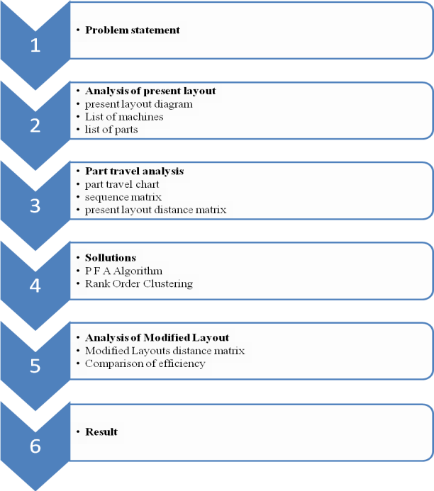
4.1 Problem Statement:
“ To improve the machines layout at the machine shop of Kerala Automobiles Ltd by applying Cellular manufacturing techniques such as P FA algorithm and Rank Order Clustering.”
The plant under consideration is The KAL production facility at Aralumoodu, in Neyyattinkara taluk, 16 kilometers south of Thiruvananthapuram. It is a Government owned and operated facility which manufactures three wheelers for passengers and goods carriers.
Study confines to the boundaries of the workshop floor of the facility which houses a net number of 32 machines and has a throughput of 40 parts that are entirely or partly manufactured in the facility.
4.2 PRESENT LAYOUT
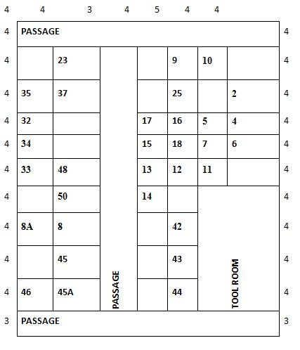
4.3 SOLUTION USING PFA ALGORITHM
This very popular algorithm for Cell formation was developed by Burbidge (1963, 1977). The input to this method is the machine component incidence relationship which is represented in the form of a zero-one or binary matrix. Burbidge used tick marks to capture the incidence relationship. Here, rows represent machine types and columns represent components (or parts). In this binary matrix, a 1 indicates that the component (or part) visits the corresponding machine. Each row corresponds to a machine type and multiple copies of the same machine are represented in a single row.
Burbidge suggests a three stage procedure to solve the cell formation problem. These are:
- Factory flow analysis: Here, the various products that are made in a given factory are decided
- Group Analysis: Here, the reorganization of the production shop floor to machine cells and part families are made.
- Line Analysis: Here other factors such as layout, capacity planning, sequencing etc are considered and the cells are actually placed in the shop floor.
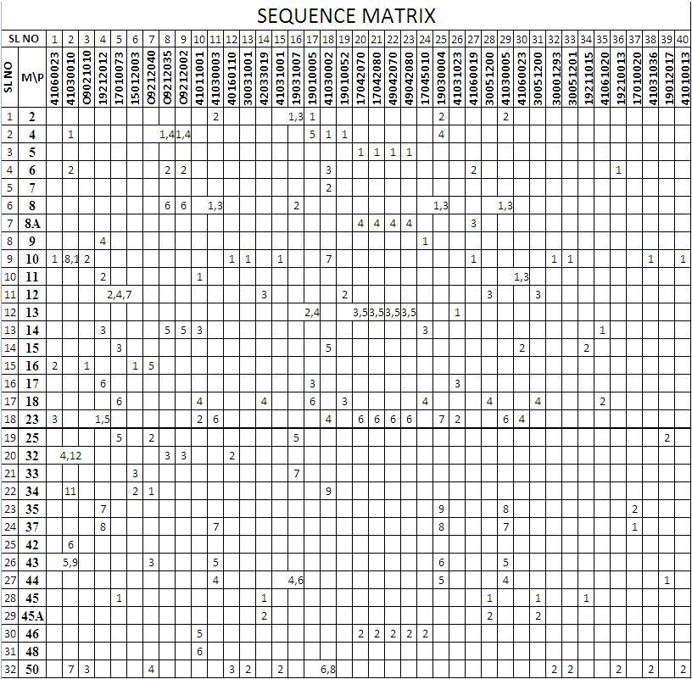

4.3.1 Initial Clusters After PFA(in matrix form)
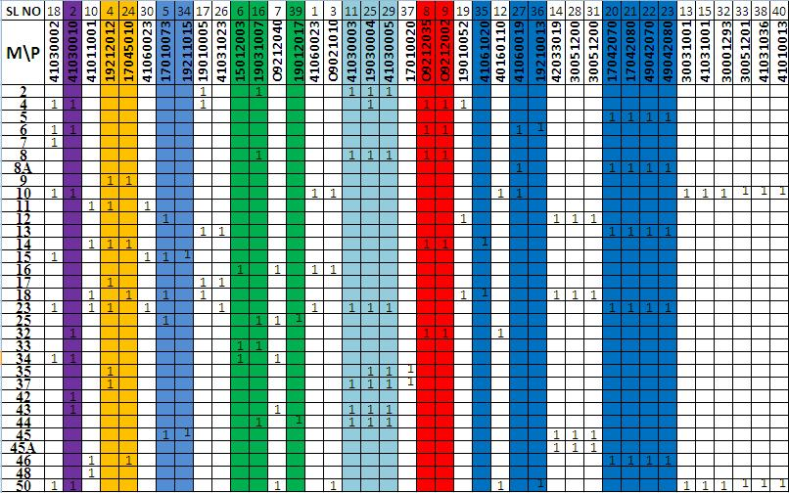

4.3.2Clusters After Grouping Sub Clusters Together
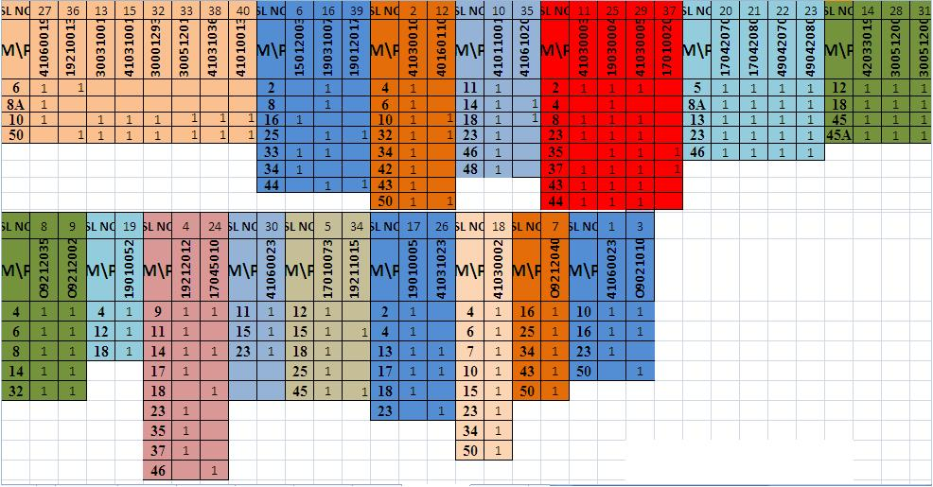

4.3.3 Final Solution by PFA
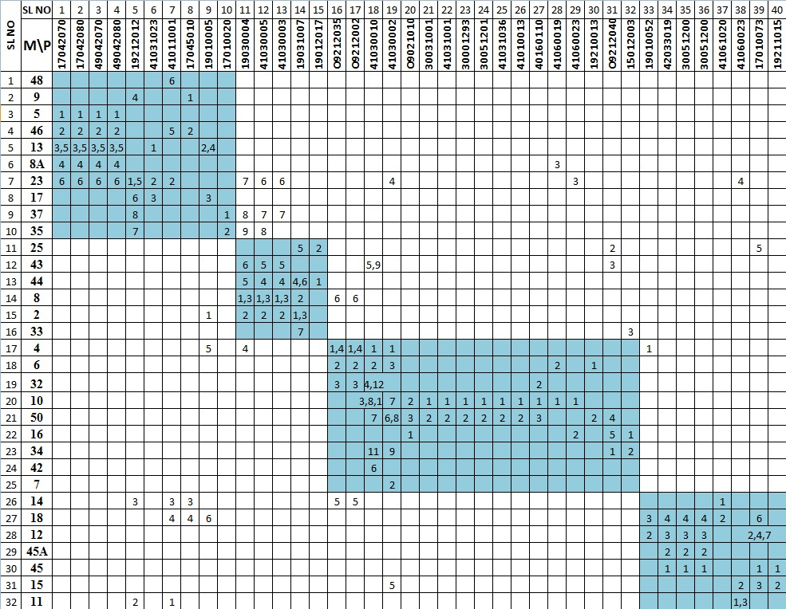

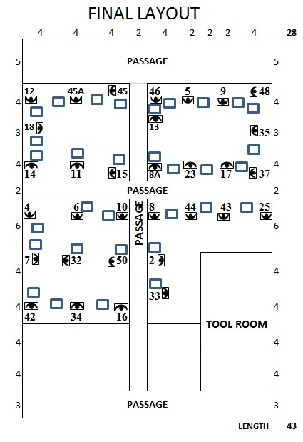

4.4 SOLUTION BY RANK ORDER CLUSTERING
This method was proposed by King (1980) to obtain part families and machine cells in Cellular Manufacturing. Here, we compute a weight for every row and sort the rows according to decreasing weights. We then compute a weight for every column and sort the columns according to decreasing weights. The steps are as follows:
- The weights given columns 1 to n are 2^{n}, 2^{n-1},...,l. For row i the weight is
w_{i} =∑^{n}_{j=1}2^{n-j}a_{ij} The rows are sorted in decreasing order of weights.
- Consider the new machine component incidence matrix after the sorting. The weights given rows 1 to m are 2^{n},2^{n-1},2^{n-2},..,1. For column j the weight is w_{j=}=∑^{m}_{i=1}2^{m-j}a_{ij}. The rows are sorted in decreasing order of weights.
- From the sorted matrix, identify the machine cells and part families.

Sorting using ROC begibs,

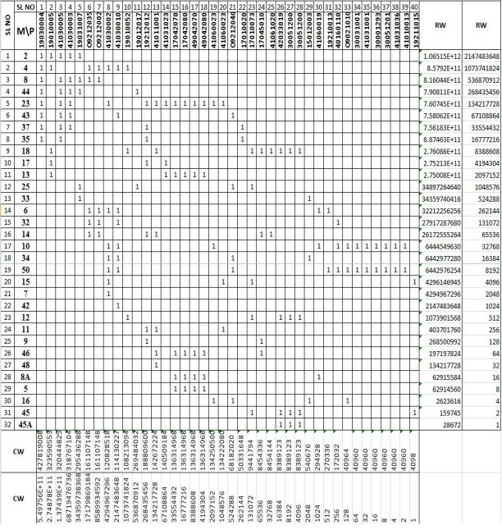

Final Solution Considering Sequence Of Operation And Manual Rearrangements
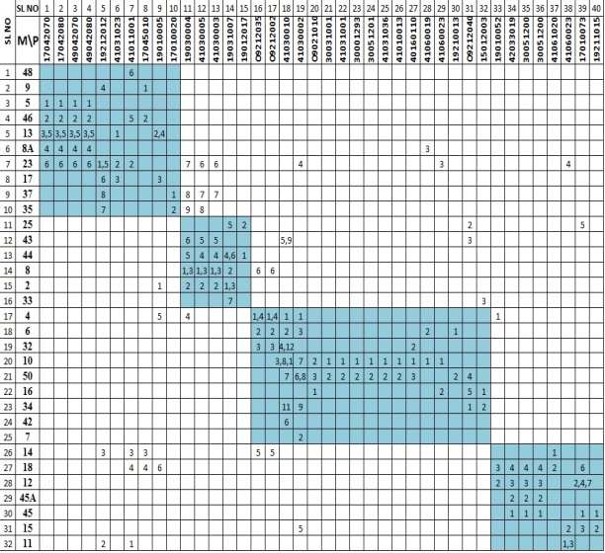

Final Layout using Rank Order Clustering
4.5 ANALYSIS OF MODIFIED LAYOUT
Now let us analyse the modified layout in comparison with the present layout. For the process the methodology adopted is to construct the distance matrix of the modified layout, calculate the net distance travelled for all the products taken together, for the initial layout and the modified layout. The difference in the amount of part travel can be considered as an indication of the change in efficiency of the layouts.

Modified layout distance matrix
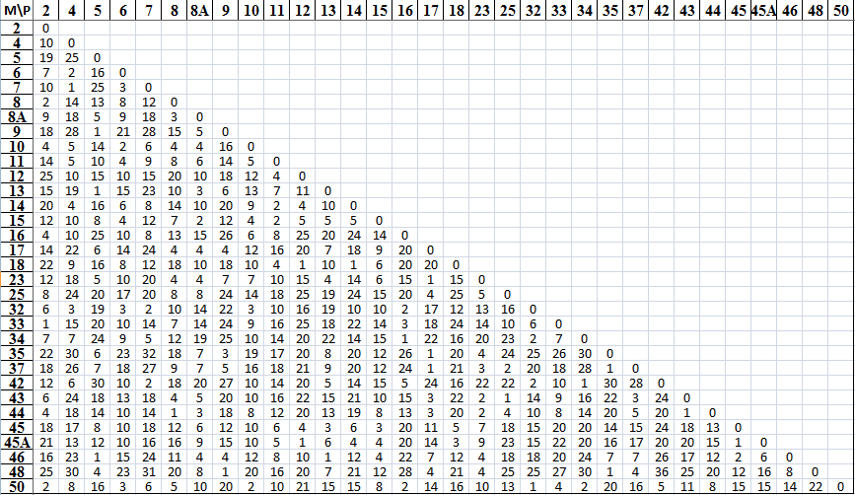

Modified Layout Part Travel Chart
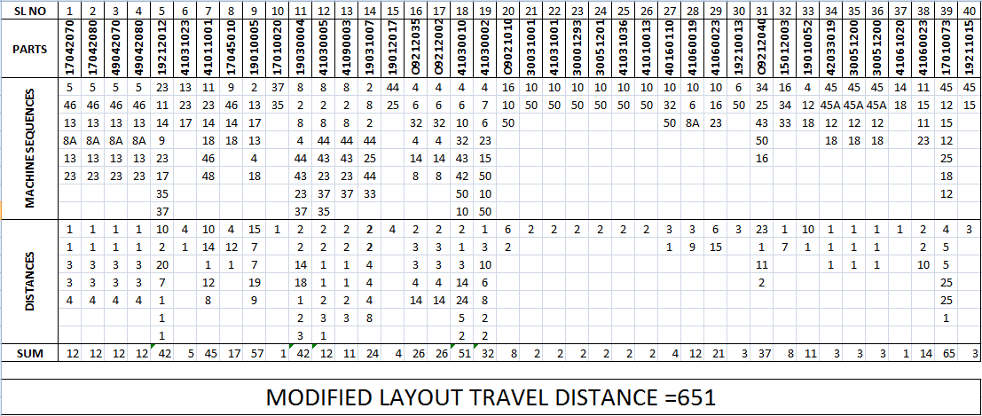
4.6 COMPARISON OF EFFICIENCIES

As a decrease in travel distance can be considered as an improvement in the efficiency of the layout, the travel distance is used as a scale to measure the amount of improvement obtained by the rearrangement using the new proposed layout.
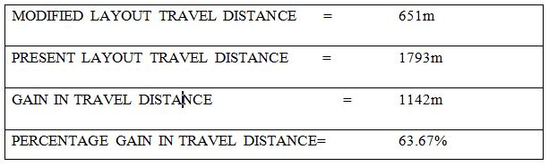
5. CONCLUSION
A gain of 63.67% is obtained in the amount of distance travelled by the parts in the case of the modified layout in comparison to the initial layout. Hence the modified layout improved the efficiency of part travel at the KAL workshop floor by 63.67%.
The amount of gain obtained by applying the cellular manufacturing technique to the shop floor is very high (as high as 63.67%). Therefore the factor of rearrangement cost considered as a disadvantage of cellular manufacturing can be written off in this case considering the large amount of saving it can provide.
The two methods considered, the PFA algorithm and The Rank Order Clustering, provided the same result. This indicates the consistency of the method as proves that both the methods are based on the same general theory of operation
References:
- JL Burbridge “Group Technology In The Engineering Industry”
- John L. Burbidge “Group Technology In The Engineering Industry”
- John L. Burbidge “The Introduction Of Group Technology”
- C. C. Gallagher, W. A. Knight “Group Technology Production Methods In Manufacture”
- E. A. Arn “Group Technology”
- Inyong Ham, Katsundo Hitomí, Teruhiko Yoshida “Group Technology”,
- Nallan C. Suresh, John M. Kay “Group Technology And Cellular Manufacturing”,

